STUDENT NAME

INSTRUCTOR NAME

COURSE NUMBER

COURSE TITLE

ASSIGNMENT TITLE

15/05/2021

INTRODUCTION
My company, Skynet Corporation, is seeking to grow its market share through an 8-year expansion plan. The company requires a specified amount of cash be available at the beginning of every year to cater for the expansion project. The expansion project will involve investing into three different types of security, to generate incomes, A, B and C. The goal of this essay is to determine the minimum amount of cash the company needs to invest into the different securities, if any, so that there will be cash at the beginning of each consecutive year as required for the expansion. Money not invested in is saved in a savings account. We will also find out the amount of money each year the company saves into the savings account. We will achieve the above by developing an Excel model that will perform the instructions above given the details available

CHAPTER 1
To meet the expansion needs for the next 8 years, the total amount of money that would need to be invested in now is $1,518,457.40. This is the minimum amount got by the linear minimization function done on the model.
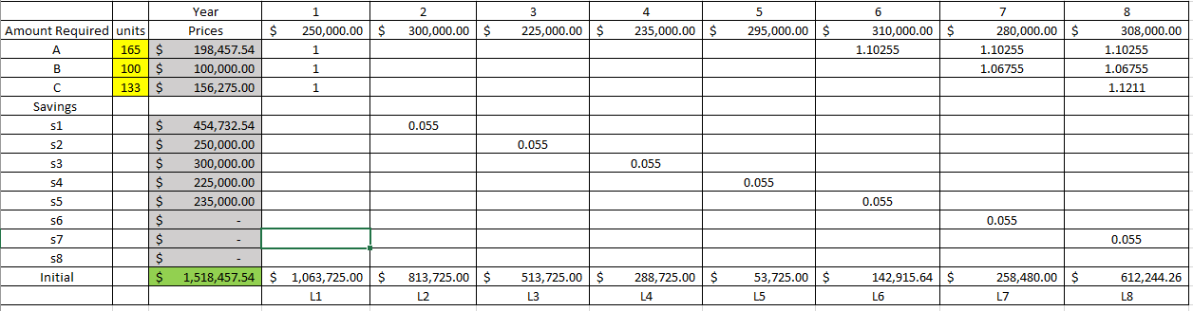
The number of units required to be invested into by the company is:
165 units for security 1
100 units for security 2
133 units for security 3
The amount invested into each security is as follows:
$1998457.54 into Security 1
$100000.00 into Security 2
156275.00 Into Security 3
The following formulas are used in the model in the calculation of these figures:
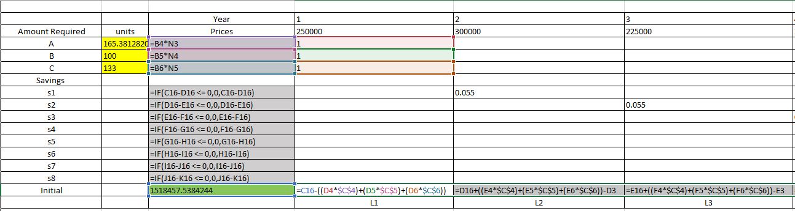
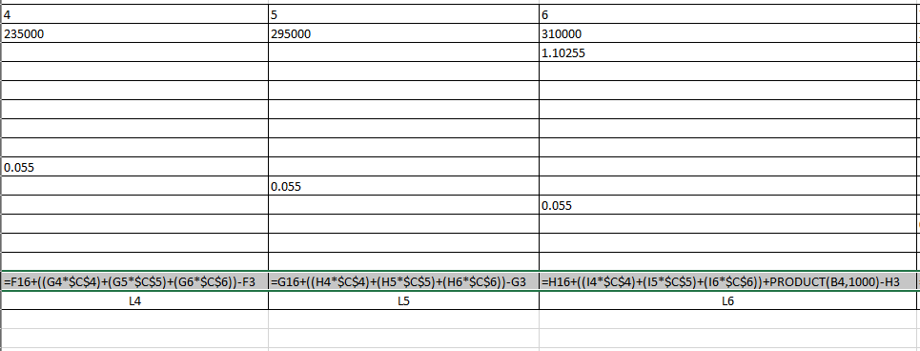
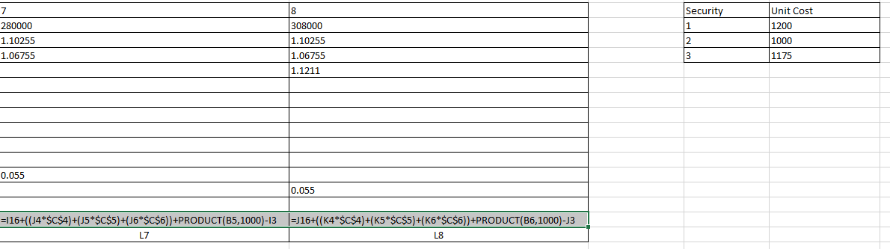
The company saves $454732.54 in after the first year, $250000 after the second, $300000 after the third year, and $225000 after the fourth year and $235000 after the fifth year. From the sixth to the eighth year the company does not save anything into the savings account.
If the company initially has $1.8 Million available to invest, then the investment plan is feasible, since $1.8 Million is above the required minimum of $1.589 Million. According to the financial model, the company will have more than the required minimums at the beginning of each of the 8 years of the expansion project, hence making the project feasible.
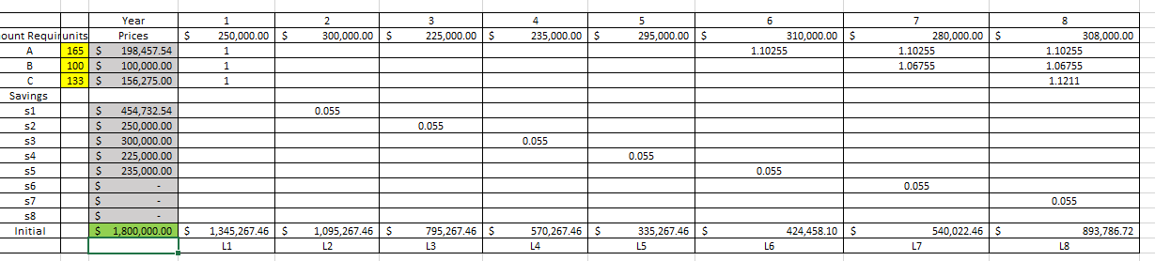

CONCLUSION
The essay above covers financial modelling using Excel Solver, a very powerful tool indeed. We have used Linear Programming to find an optimum solution to a financial allocation problem that will be used by Skynet Corporation in making its investment decisions with regards to the expansion projects.
From this assignment, I have been able to appreciate the model forming process in excel. Since the model’s success will fully depend on the data it is given, forming a good model should be the most important, and truthfully, time consuming task of the whole process. I have also been able to appreciate Excel’s data manipulation tools, specifically, Solver which really simplifies linear programming through the software itself, provided the information provided is correct.

REFERENCES
Excel Solver Tutorial - Step by Step Easy to use guide for Excel's Solver. solver. (2020, December 21). https://www.solver.com/solver-tutorial-using-solver.
Hennegar, A. (2021, May 13). Learn How to Use Excel Solver (Includes sample worksheet). Productivity Portfolio. https://www.timeatlas.com/excel-solver-quick-guide/.
Linear Programming with Spreadsheets. DataCamp Community. (n.d.). https://www.datacamp.com/community/tutorials/linear-programming-with-spreadsheets.

